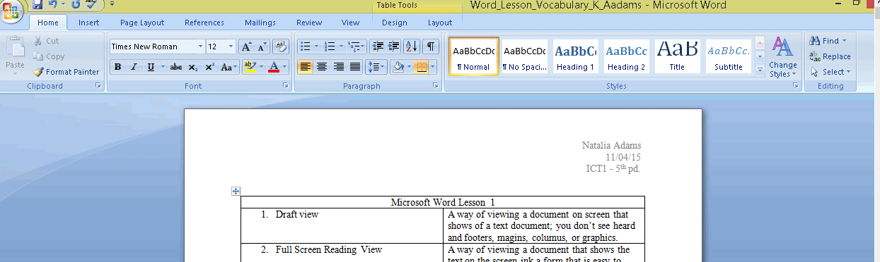

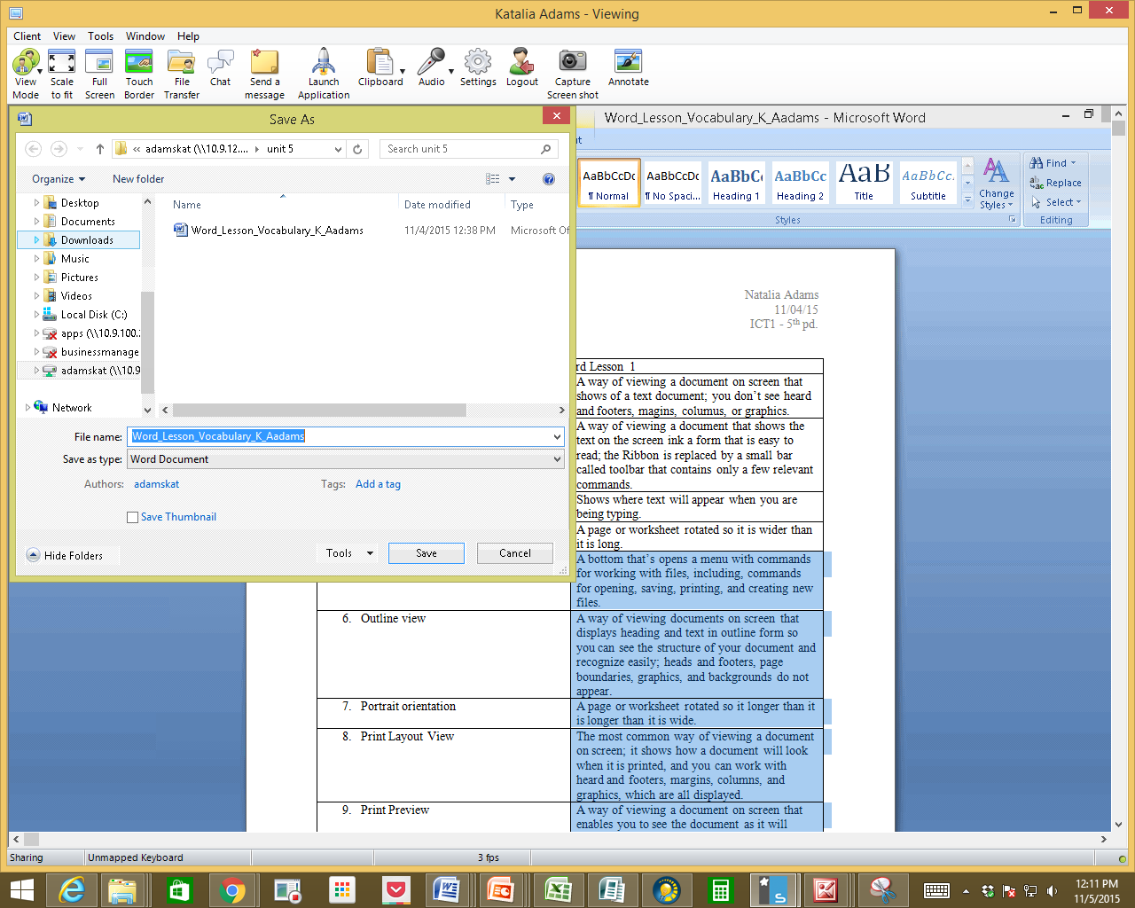
Make sure you know where your item you want to submit is saved. You do this by clicking the Office Button Save-as, check your breadcrumbs
Make sure it is saved(by clicking on the save disk or office button save)
Return to the assignment in Canvas
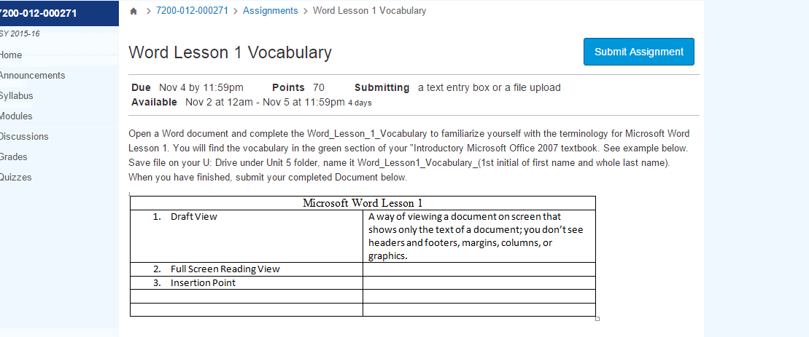
You will click on the blue “Submit Assignment” button.
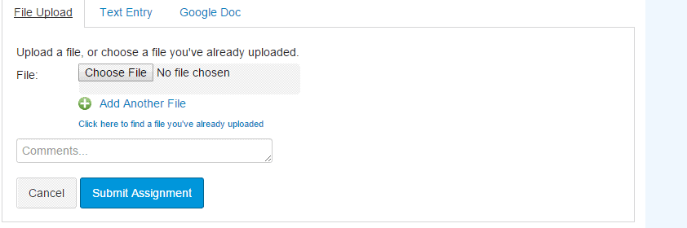
The tab you pick depend on the required type of submission. For this assignment it is a file upload from Word. Click on the “File Upload” tab for this assignment. Click the “Choose File” button which brings up the “Open” dialog box (see below).
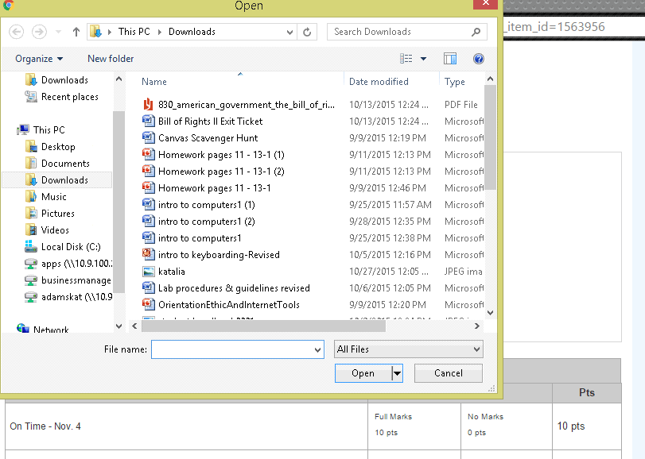
Once this box is open browse to the location of the saved file. Double click on the file once it is located. (See below)
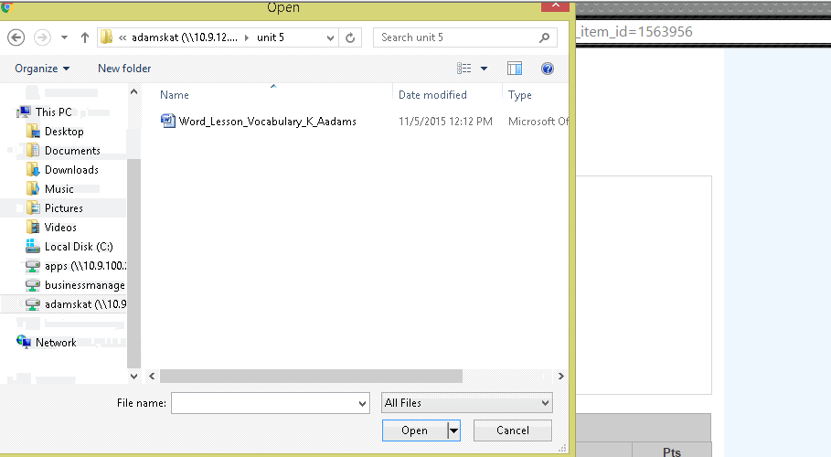
Once you double click on the file name it will appear next to the “Choose File” box. (See below)
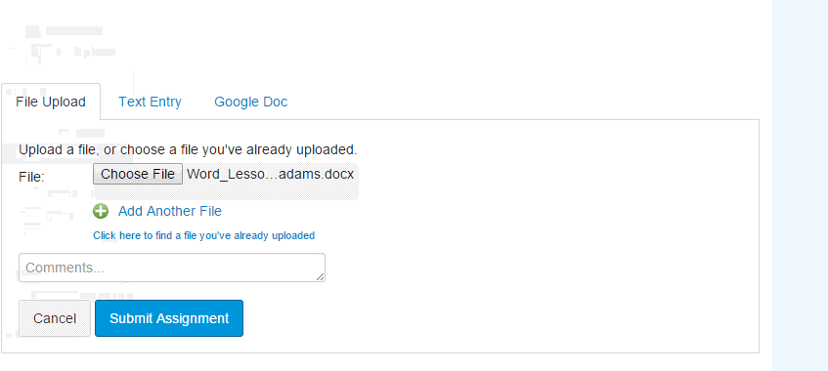
Once the right file is beside the “Choose File” box click the submit button. The system will think for a minute then you can click the blue “Submit Assignment” button. Once submitted the system will take you back to the top of the screen to the “Submission” box that will confirm that the item was submitted. (see below)
