 | Active 2014-2015 | Active 2015-2016 | Active 2016-2017
SB Policy 3801  Policies for Subject Area Testing  Not retroactive. | Students shall not be required to pass any end-of-course Subject Area Test in a course for which the student earns or receives credit in a Mississippi public school as a requirement for graduation. Student performance on the end-of-course Subject Area Test shall be considered, along with the overall course grade based on the SBE approved Concordance Table as referenced in State Board Policy 3803 and provided to school districts by the MDE.
SB Policy 3802  Policies for Carnegie Unit Credit  Not Retroactive |  | All students enrolled in one (1) of the four (4) end-of-course Subject Area Test courses must pass the course and participate in the applicable end-of-course Subject Area Test in order to earn the Carnegie Unit. No opting out of testing if Carnegie unit is desired.
SB Policy 3803  Assessments Required for Graduation  Removes passing an end-of-course Subject Area Test as a requirement for graduation and incorporates the score on the applicable assessment into the final grade in the course. | - All students must take end of course test.  - Students shall graduate by passing the course and meeting one (1) of the following options:  - Passing the applicable end-of-course Subject Area Test; or  - Using one of the options outlined in State Board Policy 3804 (Retroactive); or  - Using the end-of-course Subject Area Test score with the overall course grade based on the SBE approved Concordance Table for each of the four (4) end-of-course Subject Area Tests as provided to school districts by the MDE. (Not Retroactive) | - Beginning with school year 2015-2016, in addition to number 2, as previously discussed, all students enrolled may achieve a combined minimum score from all four end-of-course Subject Area Tests based on the SBE approved Concordance Table to meet the requirement for graduation in lieu of passing each applicable end-of-course Subject Area Test. (Not Retroactive) | - Beginning with school year 2016-2017, all students enrolled in an end-of-course Subject Area Test course for the first time must participate in the assessment in order to earn the Carnegie Unit. The assessment score will constitute 25% of the student's final grade in the course. (Not Retroactive)  - Any Mississippi public school student who fails to pass a required end-of-course Subject Area Test, prior to school year 2016-2017, will be offered opportunities to retake the test. (Not Retroactive)
SB Policy 3804  Additional Assessment Options for Meeting End-of-Course Subject Area Test Graduation Requirements  Provides approved options for students to meet high school end-of-course Subject Area Test requirements for graduation through approved alternate measures.  Retroactive | The revision allows a student to meet the graduation requirements once he or she has failed to pass any required end-of-course Subject Area Test one (1) time.  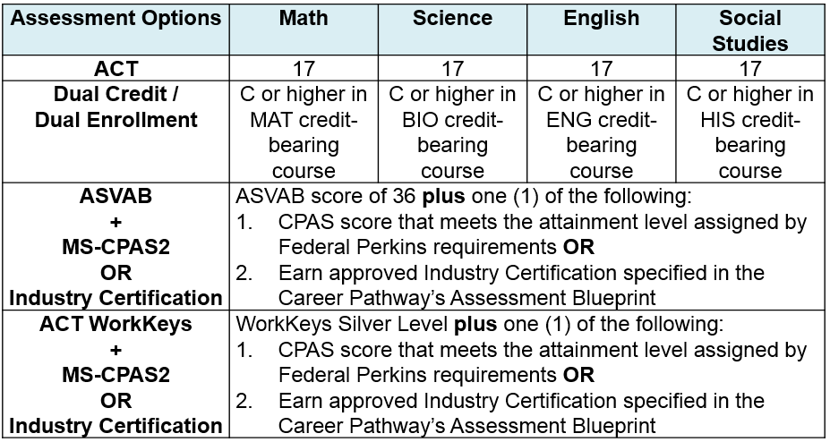 |  | SB Policy 3804 ends with the implementation of the 2016-2017 revision of SB Policy 3803.

